11.4 Volume GP 1 All images captured at 110%

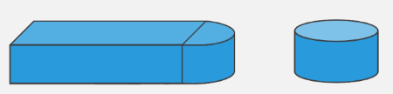

Used this images but switched the backgrounds to white in paint.net

RADIUS

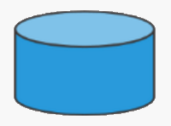

DIAMETER

HEIGHT

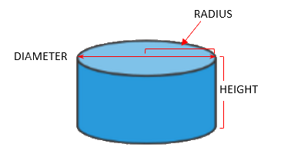

Captured the image above and colored the background white in paint.net

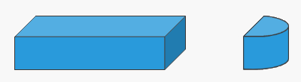

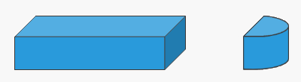

RADIUS

WIDTH

LENGTH

HEIGHT

HEIGHT

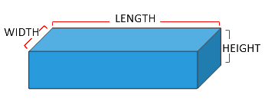

Captured the image above and colored the background white in paint.net

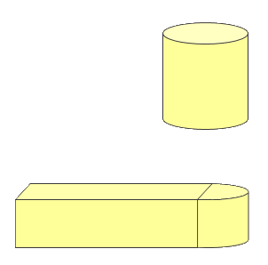

14 feet

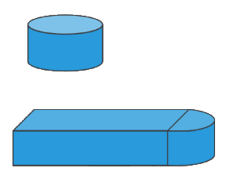

9 feet

HOT TUB

POOL

30 feet

18 feet

5 feet

5 feet

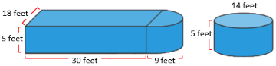

Constructed in paint.net from the images above and resized to fit

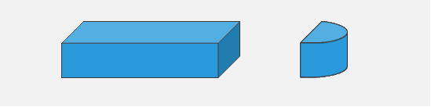

18 feet

5 feet

5 feet

30 feet

9 feet

Image above captured and switched to white background in paint.net and then resized.

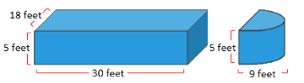



Constructed in word from image above

9 feet

18 feet

5 feet

14 feet

14 feet

5 feet

30 feet

